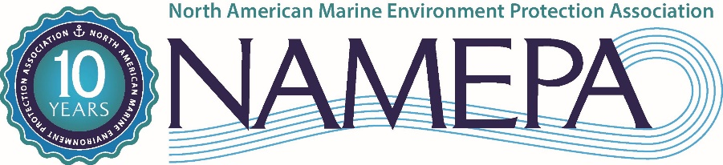

FOR IMMEDIATE RELEASE
NAMEPA Celebrates 10 years of efforts to “Save our Seas”
Conference and Awards Dinner takes maritime “Back to the Future”

September 25, 2017 – Carleen Lyden Walker, Co-Founder and Executive Director of North American Marine Environment Protection Association (NAMEPA) announced the celebration of NAMEPA’s 10th Anniversary to be held on October 26th aboard the Hornblower Infinity at Pier 40 in New York. There will be an all-day conference entitled “Back to the Future in Maritime” followed by an Awards Dinner recognizing the achievements of maritime entities to “Save Our Seas” as well as students who won the joint American Salvage Association/NAMEPA Science Fair.
“10 years ago, Clay Maitland and I saw the opportunity for the maritime community to demonstrate its commitment to protecting the marine environment,” reflected Carleen Lyden Walker. “We founded NAMEPA to facilitate that commitment, increase the activity and education around protecting the oceans, rivers, lakes and waterways, as well as educate the public about the value proposition of the maritime industry to global society. We started with 33 FOCs (Friends of Carleen and Clay) and have grown to 200 members from all over the globe, and which include some of the biggest names in the maritime world. Our footprint has grown to include activities in Canada, the United States, Mexico, the Caribbean and Bermuda. Our early vision for the organization has been surpassed by the vision of a committed Board of Directors, our members, strategic partners and supporters. We are grateful for their investment to “Save our Seas”.”
“Looking back at the last ten years, NAMEPA has provided steadfast leadership and commitment toward preserving and protecting the fragile maritime environment,” stated United States Coast Guard Commandant Admiral Paul F. Zukunft. “NAMEPA has fostered important partnerships with government and industry stakeholders to promote industry best practices and has developed vital education outreach programs touching thousands of students, seafarers, and port community residents. As we look to the future of profound challenges and transformations over the next decade, we are excited to continue our important journey together as stewards of the maritime environment.”
Since its inception 10 years ago, NAMEPA has grown in membership and in programing. Not only does it reach out to connect industry with other stakeholders committed to protecting the marine environment, but it also reaches the public with programs and activities that increase awareness of the marine industry and its value to their daily lives.
The 10th Anniversary Conference will examine where our industry has been in the past 10 years, take stock of where we are today, and look to see what lies ahead. Speakers include Michael Webber of Wells Fargo, Ole Chr. Schroder of Scorpio Group, RADM John Nadeau of the USCG, Cynthia Hudson of HudsonAnalytix, Jim Stanka of Envirocleanse, Joan Bondareff and Jeanne Grasso of Blank Rome, Alexandra Anagnostis of Total Marine Solutions, Christian Mollitor of LISCR, Captain Anuj Chopra of RightShip, Christina DeSimone of FutureCare and Rev. Marsh Drege of NAMMA. In a Senior Leadership Roundtable, the conference will also include many representatives of NAMEPA’s Marine Environment Protection Awards including Scorpio Group, Cargill, T&T Salvage, OAS-CIP, RAC/REMITAC, LISCR, and Cal Maritime. Clay Maitland will also receive the Lifetime Achievement Award for his tremendous body of work in the maritime industry.
“Had we stopped with our original vision of NAMEPA, it would not be the richly integrated, productive organization it is today,” stated Founding Chairman Clay Maitland. “NAMEPA has grown to be an asset to the maritime industry in its outreach and education. It enables our industry to be seen as responsible global citizens, and acts as a portal between groups which facilitates understanding and appreciation for what we do. We are grateful that the maritime industry has embraced NAMEPA and supported its work and mission.”
To learn more about attending the 10th Anniversary Conference and Awards Dinner, please go to NAMEPA 10th ANNIVERSARY CONFERENCE AND DINNER. Sponsorships and dinner tables are still available along with individual registrations.
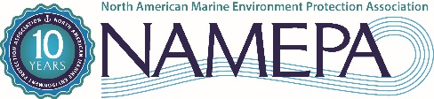
The North American Marine Environment Protection Association (NAMEPA) is a marine industry-led organization of environmental stewards preserving the marine environment by promoting sustainable marine industry best practices and educating seafarers, students and the public about the need and strategies for protecting global ocean, lake and river resources. Visit us at: www.namepa.net

Media inquiries: Carleen Lyden Walker +203 255 4686 executivedirector@namepa.net

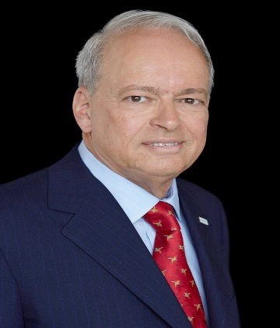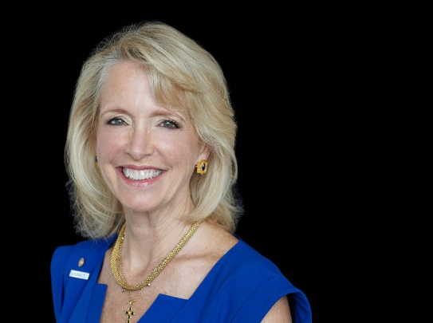

NAMEPA Co-Founders Clay Maitland and Carleen Lyden Walker

